**Time series Econometrics: Detailed Analysis of the given data set using plot graph, Augmented Dickey-Fuller Test & GLS - Augmented Dickey-Fuller Test**.

**Name:** Anumoy Modak

**Roll No**.: ME22002

**Paper:** Time Series Econometrics (TSEC)

**Prof (Dr.) Sandip Sarkar.**

**Data Used: assignments_2.dta**

1. **A) *Plotting variable xit. Writing views regarding stationarity****.*

*-*

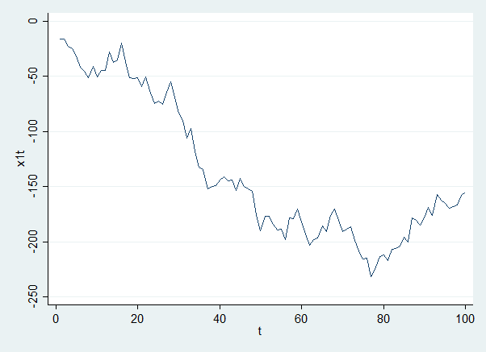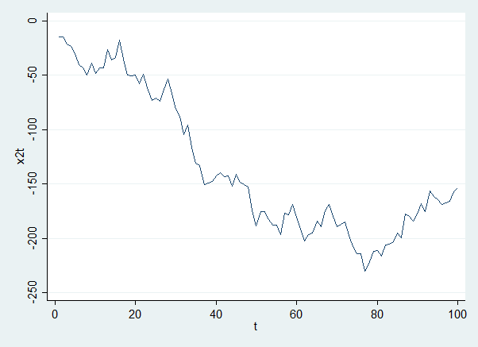

Graph The above graph appears non-stationary as it has a stochastic time trend.

Graph The above graph appears non-stationary as it has a stochastic time trend.

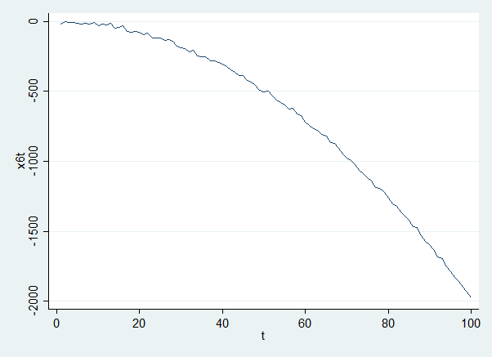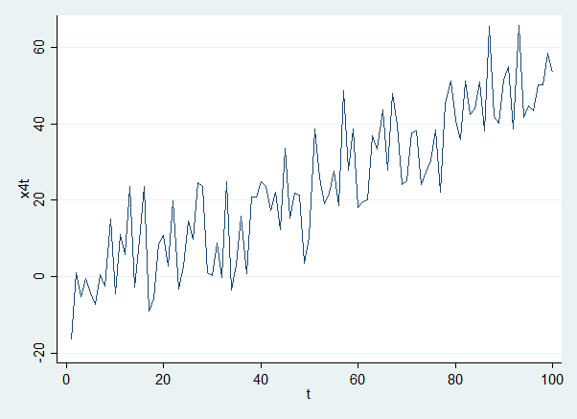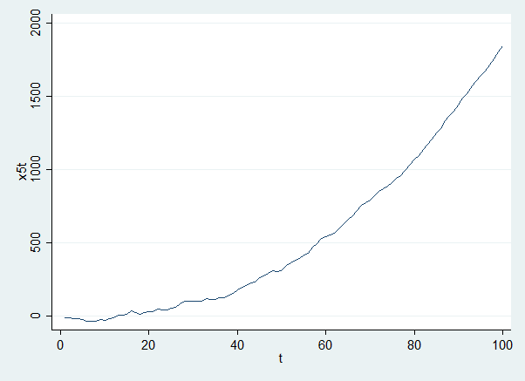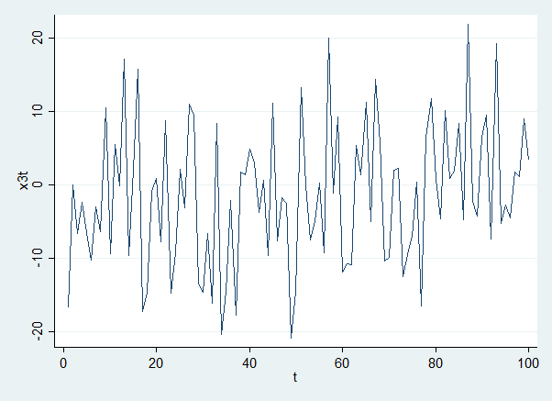

Graph 6: The above graph is non-stationary but its log values are trend stationary

Graph 4 The above graph appears trend stationary with a rising time trend.

Graph 5 The above figure is non stationary but its log values are trend stationary.

Graph 3 The above graph appears trend stationary with a rising time trend.

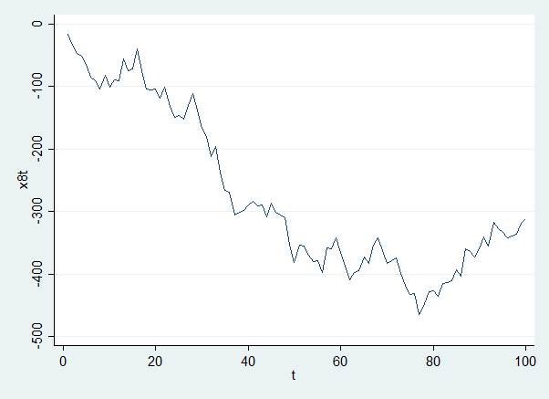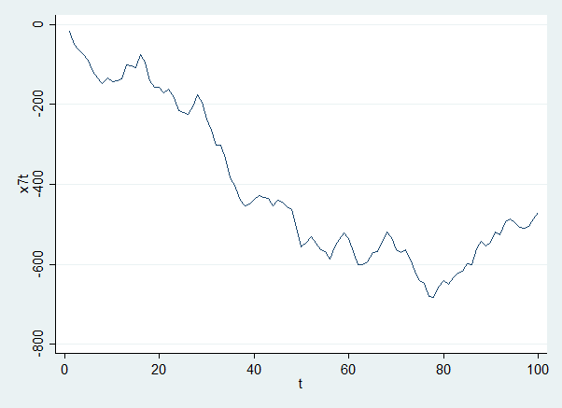

Graph 8: The above graph appears non-stationary as it has a stochastic time trend.

Graph 7: The above graph appears non-stationary as it has a stochastic time trend.

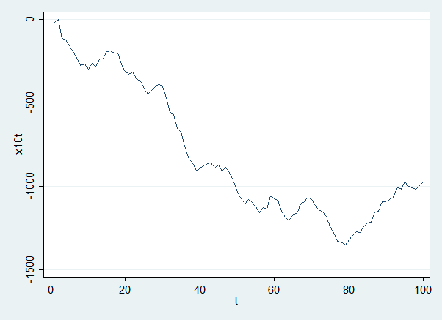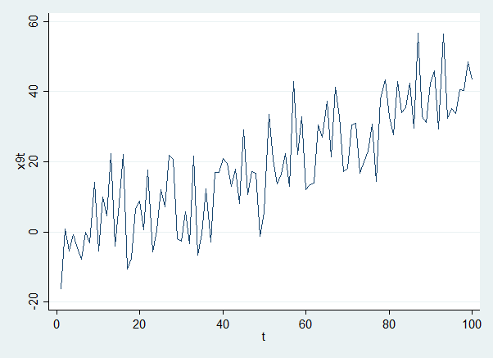

Graph 10: The above graph appears non-stationary as it has a stochastic time trend.

Graph 9: The above graph appears non-stationary as it has a stochastic time trend.

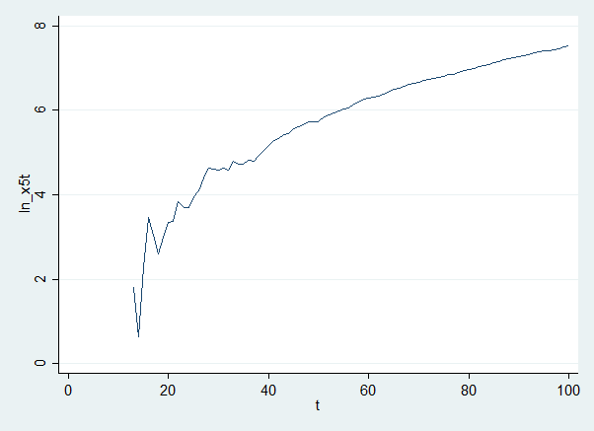 **Special case for x5t & x6t :**

Figure 11: format for conversion from x5t to ln(x5t)

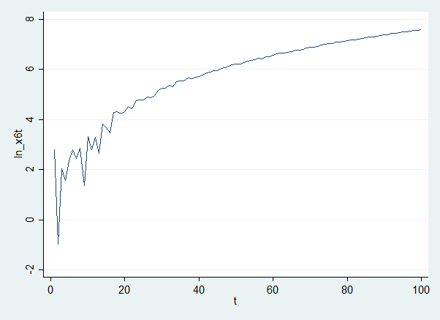

Figure 12: format for conversion from x6t to ln(x6t)

1. b) ***Checking whether xit is stationary or not using Dicky Fuller and Elliot Rothenberg and Stock (DFGLS) test statistics.***

- We know the augmented Dickey-Fuller test is a test of stationarity that checks if the coefficient (a1) of the independent (yt-1) in an autoregressive model is equal to 1.

yt = a1.yt-1+ εt

i.e. D.yt = γ.yt-1+εt

Where, D.yt  = yt – yt-1

γ = coefficient. (1-a1)

εt = error term at time period ‘t’.

# **Null Hypothesis**:

H0: a1 = 1

( a1 - 1) = 0;

# **Alternate Hypothesis:**

H1: a1 ≠ 1

( a1 - 1) ≠ 0

|  |  |  |  |  |
| --- | --- | --- | --- | --- |
| Serial No. | Variables | Dickey-Fuller Statistic (With Trend) | Dickey-Fuller Statistic (Without Trend) | GLS-ADF calculated Statistic (significant lag) |
| 1 | x1t | -0.309 | -2.003 | -1.017 (at 12 lag) |
| 2 | x2t | -0.309 | -2.004 | -1.017 (at 12 lag) |
| 3 | x3t | -11.018*** | -10.636*** | -6.795***(at 1 lag) |
| 4 | x4t | -3.530** | -0.729 | -6.795***(at 1 lag) |
| 5 | x5t | 1.101 | 7.717 | -2.235 (at 12 lag) |
| 6 | x6t | -0.023 | 1.552 | -2.497 (at 9 lag) |
| 7 | x7t | -0.230 | -1.944 | -1.069 (at 12 lag) |
| 8 | x8t | -0.321 | -2.014 | -0.920 (at 12 lag) |
| 9 | x9t | -3.530** | -0.871 | -6.795*** (at 1 lag) |
| 10 | x10t | 0.842 | -1.792 | -1.157 (at 12 lag) |
| 11 | Ln(x5t) | -8.198*** | -5.265*** | -1.446 (at 6 lag) |
| 12 | Ln(x6t) | -7.846*** | -4.900*** | -1.972 (at 12 lag) |

**[Table 1 Significance at : 1% = ***, 5% = **, 10% = *]**

**1.c) *Writing a detailed note on a mentioned Observation***

* Non-stationary is stationary which has a unit root i.e., for:

Yt = a0 + a1.yt-1 + εt

Where, |a1| < 1

The stationary process has a constant mean, variance and co-variance is time-invariant (may be dependent on lag ‘k’ length). Now, based on the definition, analyzing the observations mentioned with the above variable.

Given variables are xit where i = 1(1)10 and checking whether all above variables ( time-series) are stationary or not using the Dicky-Fuller test & Elliot, Rothenberg and stock test ( ADF & DFGLS test respectively )

**According to the DF: t-statistic**, when the t-calculated > t-tabulated value, then we consider the given variable stationary and reject the null hypothesis further we check separately for ‘trend’. In some cases, the variables show stationary with a trend, some show without a trend and some are insignificant values i.e., non-stationary. [ **Note: Variables which are not stationary but their trend value is significant which means that the trend has an effect on the variable**]

Now, the analysis of the stationarity of the given variables are as follows:

1. X1t = x1t is not stationary by ADF test with trend (-0.309) ADF test (-2.003) or by GLS ADF test at lag 12 (-1.017)
2. X2t = x2t is non-stationary by ADF with trend (-0.0309), ADF test (-2.004) and by GLS ADF test at lag 12 (-1.017)

**[Note: x1t and x2t are the same time series with diff. magnitudes (they are derived from the same non-stationary process) ]**

1. X3t = x3t is stationary with ADF with trend ( -11.018 at 1%), ADF without trend (-10.636 at 1%) and GLS ADF at lag 1 (-6.795 at 1%).
2. X4t = x4t is significant by ADF with trend (-3.530 at 5% significance), is not stationary by ADF without trend ( -0.729) and is stationary by GLS ADF at 1 lag ( -6.795 at 1% significance)
3. X5t = it is not stationary by ADF with trend (1.101), ADF without trend (7.717) and by GLS ADF at lag 12 (-2.35).
4. X6t = is not stationary by ADF with trend (-0.023), ADF without trend (1.552) and by GLS ADF at lag 9 (-2.497)
5. X7t = is not stationary by ADF with trend (-0.230), ADF without trend (-1.944) and by GLS ADF at lag 12 (-1.069)
6. X8t = is not stationary by ADF with trend (-0.321), ADF without trend (-2.014) and by GLS ADF at lag 12 (-0.920)
7. X9t = x4t is significant by ADF with trend (-3.530 at 5% significance), is not stationary by ADF without trend ( -0.871) and is stationary by GLS ADF at 1 lag ( -6.795 at 1% significance)
8. X10t = x1t is not stationary by ADF test with trend (0.842), ADF test (-1.792) or by GLS ADF test at lag 12 (-1.57)
9. Ln_x5t = is stationary by dicky-fuller with trend ( -8.198 at 1% significance), ADF without trend is stationary ( -5.265 at 1%) & is non-stationary by GLS ADF at lag 6 ( -1.446)
10. Ln_x6t = = is stationary by dicky-fuller with trend ( -7.846 at 1% significance), ADF without trend is stationary ( -4.900 at 1%) & is non-stationary by GLS ADF at lag 12 ( -1.972)

**[Note: a) x3t, x4t, x9t are similar time series with x3t having no time trend. X4t and x9t have time trends of different magnitudes affecting them.**

**b) ln_5t & ln_6t were taken under suspicion of showing an exponential trend of x5t and x6t. Such a trend is whoever doesn’t seem to exist.]**

# **Reference:**



Figure 13: Time_Series_Econometrics_Assignment_smcl.pdf